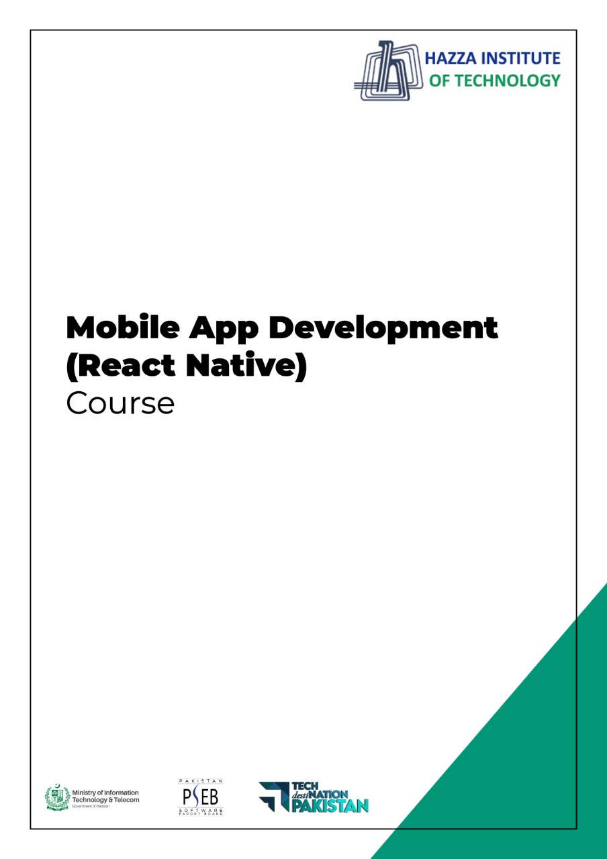

**(Flutter)**

Flutter Lab 5 (Session 2)

**Total Time:**

**3 hours ( session-2)**

**Pre-Lab Activities:**

* + Basics of Flutter Scoffold appbar Widget

**Learning Outcomes:**

* + Learn layout design
  + Learn lisTtile for Design
  + Learn use of external resources.

**Student Activities:**

* + Complete the pre-lab activities
  + Practicing Basic Widgets
  + 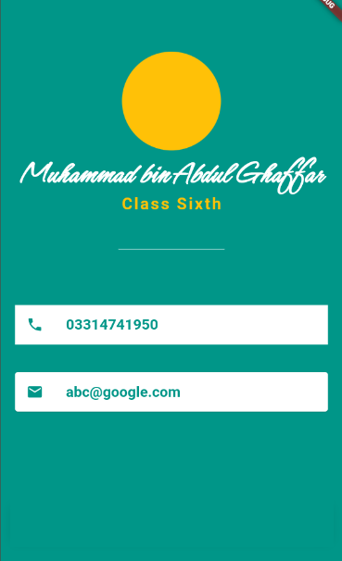Practice external font resources

**Lab Tasks -2:**

* Design the UI accoriding to below given image.
* Display your picture in CircleAvatar
* Use external font (google font) for name
* Use the listTile for phone and email icon and text.
* Use this desing for appbar drawer.

**Lab Solutions:**

**LAB 5.2 :**

**CODE:**

|  |
| --- |
| import 'dart:ui';  import 'package:flutter/cupertino.dart';  import 'package:flutter/material.dart';  void main() {  runApp(const MyApp());  }  class MyApp extends StatelessWidget {  const MyApp({Key? key}) : super(key: key);  // This widget is the root of your application.  @override  Widget build(BuildContext context) {  return MaterialApp(  title: 'Portfolew',  home: Scaffold(  backgroundColor: Colors.teal,  body: SafeArea(  child: Column(  mainAxisAlignment: MainAxisAlignment.center,  children: [  CircleAvatar(  backgroundColor: Colors.amber,  radius: 70,  backgroundImage: AssetImage(''),  ),  Text('Muhammad bin Abdul Ghaffar',style: TextStyle(  fontFamily: 'Schyler',  fontSize: 40,  fontWeight: FontWeight.bold,  color: Colors.white,  ),),  Text('Class Sixth', style: TextStyle(  color: Colors.amber,  fontSize: 20, letterSpacing: 2.5, fontWeight: FontWeight.bold),),  SizedBox(width: 150, height: 100,  child: Divider(color: Colors.white70),),  // Container with ListTile without rounded corner  Container(  color: Colors.white,  margin: EdgeInsets.symmetric(vertical: 10, horizontal: 20),  child: ListTile(  title: Text('03314741950', style: TextStyle(color: Colors.teal, fontWeight: FontWeight.bold, fontSize: 18,), ),  leading: Icon(Icons.phone, color: Colors.teal,),  ),  ),  // card with ListTile with round corner  Card(  color: Colors.white,  margin: EdgeInsets.symmetric(vertical: 10, horizontal: 20),  child: ListTile(  title: Text('abc@google.com', style: TextStyle(color: Colors.teal, fontWeight: FontWeight.bold, fontSize: 18),),  leading: Icon(Icons.email, color: Colors.teal,),  )),  ),  ],  ),  ),  )  );  }  } |